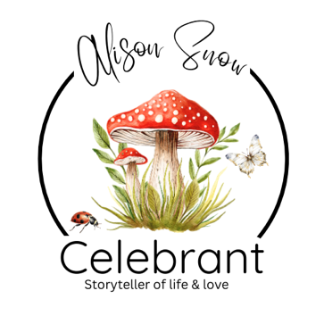

A Parents' Guide to Naming Ceremonies

Celebrating New Beginnings, Love and Family

Congratulations!
Whether you are welcoming a new baby, celebrating the arrival of an adopted child, bringing together a blended family or simply looking for a meaningful way to introduce your child to the people who love them, a Naming Ceremony is a wonderful way to mark this special chapter in your family's story.
Unlike a religious christening or baptism, a Naming Ceremony is a personal, non-religious celebration. There are no rules, no expectations and no prescribed format. Instead, it is designed entirely around you, your child and the values you hope will guide your family for years to come.
Every ceremony is unique because every family is unique.

Why Have a Naming Ceremony?
Children are welcomed into our lives with immense love, hope and excitement.
A Naming Ceremony offers the opportunity to pause, gather together and celebrate that joy with family and friends.
It is a chance to:
- Officially welcome your child into your family and community.
- Celebrate their name and the story behind it.
- Introduce the important people in their lives.
- Recognise grandparents, siblings and extended family.
- Appoint Guide-Parents or other special adults.
- Share your hopes and dreams for your child's future.
- Create memories that will be treasured for a lifetime.
For many families, it becomes one of the happiest days of their child's early years.

There Are No Rules
One of the greatest joys of a Naming Ceremony is that it can be as formal or as relaxed as you wish.
It might take place:

- In your home or garden.
- At a village hall.
- In a favourite hotel.
- At the beach.
- In woodland.
- At a country house.
- In a local park (where permitted).
- Anywhere that feels special to your family.

Likewise, your ceremony can last twenty minutes or over an hour.
You choose what feels right.

Your Ceremony, Your Story
As your celebrant, my role is to get to know your family and create a ceremony that genuinely reflects you.
Together, we'll explore:
- Your family's story.
- Why you chose your child's name.
- What makes your child unique.
- The hopes you have for their future.
- The people who will help guide and support them.
No two ceremonies are ever the same because no two families are the same.

Choosing Guide-Parents
Many parents choose to appoint Guide-Parents during the ceremony.
Unlike traditional Godparents, Guide-Parents do not have a religious role. Instead, they are people you trust to encourage, support and help your child as they grow.
They may make promises during the ceremony and become lifelong mentors, cheerleaders and trusted friends.
Choose people who will enrich your child's life, not simply because they are relatives or lifelong friends, but because they will genuinely be present throughout your child's journey.

Including Brothers and Sisters
Naming Ceremonies are wonderful opportunities to celebrate the whole family.
Siblings can:
- Help welcome the new baby.
- Read a poem.
- Light a candle.
- Present a gift.
- Make their own promises.
- Take part in a family ritual.
This helps everyone feel included in the celebration.

Grandparents and Family
Grandparents often play a very special role in a child's life.
Some families invite them to:
- Share a reading.
- Offer words of wisdom.
- Make promises.
- Present a keepsake.
- Sign the Naming Certificate.
Extended family and close friends can also be involved in whatever way feels meaningful.

Creating Lasting Memories
Many families choose to include symbolic rituals within their ceremony.
Popular ideas include:

A Wish Tree
Guests write hopes and wishes for your child's future and hang them on a decorative tree.

Time Capsule
Letters, photographs and small keepsakes are sealed away to be opened on a future birthday.

Memory Book
Family and friends write messages that your child can read as they grow older.

Candle Ceremony
Lighting candles symbolises the love and guidance surrounding your child.

Sand Ceremony
Different coloured sands are poured together, representing the joining of family and friends who will help shape your child's future.

Tree Planting
A tree or shrub planted on the day grows alongside your child as a lasting reminder of new beginnings.

Promise Stones
Guests write words such as Love, Courage, Kindness or Adventure onto pebbles or wooden hearts for your child to keep.
The possibilities are endless, and together we can create something that is uniquely yours.

Music, Readings and Poetry
Music helps create atmosphere and emotion.
Some families choose classical pieces, others favourite songs or something with special meaning.
Readings might include:
- Poems.
- Children's books.
- Letters to your child.
- Family blessings.
- Original writing.
There is no right or wrong choice—only what feels right for your family.

A Celebration to Remember
Many families combine the ceremony with a relaxed celebration afterwards.
Whether it's afternoon tea, a picnic in the park, a garden barbecue or a family lunch, it provides an opportunity for everyone to continue celebrating together.
The ceremony marks the beginning, the memories continue long afterwards.

Frequently Asked Questions
Is a Naming Ceremony legally binding?
No. Your child's birth registration is the legal recognition of their name. A Naming Ceremony is a symbolic celebration.
What age should my child be?
Any age.
Some families hold ceremonies for newborn babies, while others celebrate toddlers, adopted children or older children who have become part of a blended family.
Can we include religious elements?
A Naming Ceremony is generally non-religious, but it can include spiritual, cultural or family traditions that are meaningful to you.
Can older children be involved?
Absolutely. Many older children enjoy making promises, reading poems or sharing their thoughts during the ceremony.

Above All...
Your Naming Ceremony is about celebrating love. It is about recognising that every child arrives in the world surrounded by hopes, dreams and people who want the very best for them.
It is a day to pause, to gather, to celebrate and to promise that whatever life may bring, this child will always be surrounded by love, encouragement and belonging.
It would be my privilege to help you create a ceremony that reflects your family, your values and the wonderful future that lies ahead.
Because every child deserves a joyful welcome, and every family deserves a celebration as unique as they are.

NOTES:

I do hope you have found this informative guide useful. I send you my congratulations and offer my services as your celebrant if you live in the Norfolk, Suffolk areas of the UK.
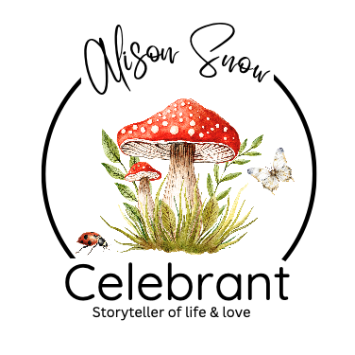
Alternatively, please feel free to contact me at any time for any information or support I can help you with, should you need it.
Blessings and love, Alison x
Alison Snow Celebrant
www.alisonsnowcelebrant.co.uk
info@alisonsnowcelebrant.co.uk
07799 807337
This guide is the intellectual property of Alison Snow, Celebrant.
Any reproduction, distribution, or use, for any other event, or purpose—whether in part or in full—is strictly prohibited without prior written consent from the author. Unauthorized use may result in legal action

