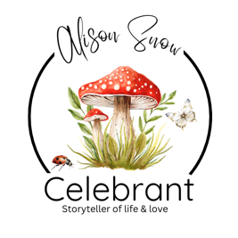
A Guide for Guide-Parents

Supporting a Child Through Life's Journey

Firstly, congratulations on being chosen as a Guide-Parent.
Being asked to take on this role is a wonderful compliment and a reflection of the trust, love and respect that the child's parents have in you. While a Naming Ceremony has no religious significance, it offers the opportunity to recognise those special people who will help nurture, encourage and support a child as they grow.
Being a Guide-Parent is not about replacing a parent. It is about becoming another trusted adult in a child's life, someone who celebrates their successes, offers reassurance during challenges and reminds them, throughout life, just how loved they are.

What Does a Guide-Parent Do?
There are no fixed rules.
Every family is different, and every Guide-Parent brings something unique to the role.
You may become someone who:
- Offers encouragement and guidance.
- Listens without judgement.
- Celebrates milestones and achievements.
- Shares hobbies, interests and life experiences.
- Creates lasting memories together.
- Provides support during difficult times.
- Helps build confidence and self-belief.
- Simply reminds the child they are loved exactly as they are.
Often, the greatest gift you can give is simply being present.

Your Role During the Naming Ceremony
Guide-Parents often play an important part in the ceremony itself.
You may be invited to:
- Read a favourite poem or reading.
- Share a few words about your hopes for the child's future.
- Introduce yourself and explain your connection with the family.
- Make a promise to the child.
- Take part in a symbolic ritual.
- Present a keepsake or gift.
- Sign the Naming Ceremony Certificate as a witness.
There is no right or wrong way to be involved. The ceremony is designed around the wishes of the family and can be as formal or relaxed as they choose.

Making Your Promise
One of the most memorable parts of the ceremony is when Guide-Parents make their promises.
These do not need to be grand or elaborate. In fact, the simplest promises are often the most meaningful.
You may wish to promise that you will:
- Always make time to listen.
- Encourage curiosity and imagination.
- Celebrate every achievement, big or small.
- Support their dreams, whatever they may be.
- Offer kindness, honesty and understanding.
- Help them find confidence in themselves.
- Be there whenever they need a friend.
- Fill their life with laughter and happy memories.
- Cheer them on through every stage of life.
- Always remind them how deeply they are loved.
Remember, your promise should reflect who you are and the relationship you hope to build.

Ideas for Ceremony Rituals
Many families enjoy including a symbolic ritual that reflects the support surrounding the child.
Some popular ideas include:

Wish Tree
Guests write hopes and wishes for the child's future before hanging them on a decorative tree. These can later be collected into a keepsake book.

Time Capsule
Family and friends contribute letters, photographs or small mementoes to be opened on a significant birthday.

Memory Book
Guests write messages, advice and memories that the child can enjoy reading as they grow older.

Candle Ceremony
Each Guide-Parent lights a candle from a central flame, symbolising the love and guidance they will offer throughout the child's life.

Pebble or Heart Ceremony
Guests write words such as "Kindness", "Courage", "Hope" or "Love" onto pebbles or wooden hearts that the child can keep as lasting reminders of the promises made.

Tree or Flower Planting
A tree, shrub or favourite flower is planted to grow alongside the child—a living symbol of love, strength and new beginnings.

Keeping the Promise Alive
The Naming Ceremony is only the beginning.
The role of a Guide-Parent grows over the years through shared experiences and small acts of kindness.
You might choose to:
- Send a birthday card every year with a personal message.
- Create a scrapbook or memory album together.
- Spend one special day together each year.
- Read the same favourite story at different ages.
- Give a meaningful book each birthday with a handwritten message inside.
- Write letters for milestone birthdays such as 10, 16, 18 or 21.
- Celebrate the anniversary of the Naming Ceremony with a small tradition.
- Take a yearly photograph together to see how you've both grown.
- Share a favourite walk, picnic or outing every year.
- Create a "Guide-Parent Journal" filled with memories, adventures and words of encouragement.
These traditions often become treasured memories that last a lifetime.

A Lasting Gift
Children may not remember every word spoken during their Naming Ceremony.
What they will remember is how they were made to feel.
The love they received.
The encouragement they were given.
The people who stood beside them.
And the adults who kept the promises they made.
As a Guide-Parent, you have the opportunity to become one of those people.
What a wonderful gift that is.
"Children may outgrow your lap, but they will never outgrow your place in their heart."

NOTES:

Being a ‘Guide-parent’ or arranging a Naming Ceremony should feel joyful, not overwhelming.
I do hope you have found this informative guide useful. I send you my best wishes and offer my services as your celebrant if you live in the Norfolk, Suffolk areas of the UK. Further areas are considered for weddings etc, so please contact me to discuss.
Alison Snow Celebrant
Creating meaningful ceremonies across Suffolk, Norfolk, the UK and beyond.
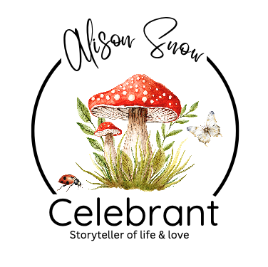

Alison Snow Celebrant
www.alisonsnowcelebrant.co.uk
info@alisonsnowcelebrant.co.uk
07799 807337

This guide is the intellectual property of Alison Snow, Celebrant.
Any reproduction, distribution, or use, for any other event, or purpose—whether in part or in full—is strictly prohibited without prior written consent from the author. Unauthorized use may result in legal action

