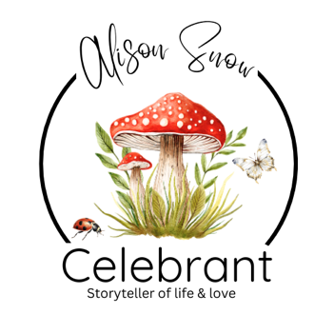

Writing a Eulogy for Your Beloved Animal
"Until one has loved an animal, a part of one's soul remains unawakened."
— Anatole France

Finding the words to say goodbye to a beloved animal can feel overwhelming. They may not have spoken our language, but they communicated in countless other ways – through a wagging tail, a gentle nuzzle, a comforting purr or simply by always being there when we needed them most.
A eulogy doesn't have to be long or perfect. It simply needs to come from the heart.

Begin with Their Story
Introduce your companion. You might include:
- Their name (and any affectionate nicknames)
- What kind of animal they were
- How and when they came into your life
- Your first memories of them

Celebrate Their Character
Think about what made them uniquely them. Were they:
- Mischievous?
- Gentle?
- Brave?
- Loyal?
- Playful?
- Independent?
- Full of personality?
These little details are often what make everyone smile.

Share Your Favourite Memories
Some of the most touching eulogies are built around simple moments. Perhaps it was:
- Their excitement when you appeared
- The way they greeted you every day
- Their favourite place to sleep
- Adventures you shared together
- Funny habits that became part of family life
- The comfort they gave during difficult times
These memories paint a picture of the life you shared.

Reflect on What They Meant to You
This is the heart of your tribute. Ask yourself:
- What did they teach you?
- How did they change your life?
- What will you miss most?
- How will you remember them?
There are no right or wrong answers—only your own.

Say Goodbye
End with a few words that feel right for you.
You may wish to thank them for their companionship, promise never to forget them, or simply tell them how deeply they were loved.
Sometimes the simplest words are the most meaningful.
"Thank you for every walk, every cuddle, every laugh and every quiet moment we shared. You gave us so much more than you could ever have known. We will carry your love with us always."

Remember...
There is no perfect eulogy, there is no perfect way to grieve, if you laugh while remembering them, that's okay. If you cry, that's okay too.
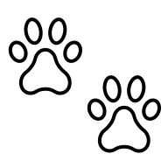
The greatest tribute you can offer is to speak honestly about the love you shared after all, our animals don't measure our words—they measure our hearts, and that love never truly leaves us.
I do hope you have found this informative guide useful. I send you my sincerest condolences if you have lost someone dear recently and offer my services as your celebrant if you live in the Norfolk, Suffolk or Cambridgeshire areas of the UK.
Alternatively, please feel free to contact me at any time for any information or support I can help you with, should you need it.
Blessings and love, Alison x
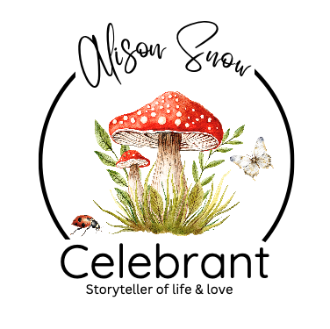
Alison Snow Celebrant
www.alisonsnowcelebrant.co.uk
info@alisonsnowcelebrant.co.uk
07799 807337
This guide is the intellectual property of Alison Snow, Celebrant.
Any reproduction, distribution, or use, for any other event, or purpose—whether in part or in full—is strictly prohibited without prior written consent from the author. Unauthorized use may result in legal action

