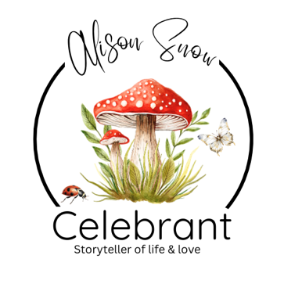

A Guide to Transition Naming Ceremonies

Celebrating Your Authentic Self

There are moments in life that deserve to be marked.
We celebrate births, marriages, anniversaries and achievements because they represent new beginnings and important chapters in our lives.
For many people, embracing their authentic gender and choosing to live openly as themselves is one of the most profound journeys they will ever undertake.
A Transition Naming Ceremony offers the opportunity to pause, reflect and celebrate that journey with the people who love and support you.
It is not about becoming someone new, it is about honouring the person you have always been.

Why Have a Ceremony?
Every transition is unique, some people choose a ceremony when they begin their transition, others wait until they have legally changed their name. Some celebrate after starting hormone treatment or following gender-affirming surgery, others simply reach a point where they feel ready to say:
"This is me."
There is no right time, only your time.
A ceremony offers a chance to:
- Celebrate your chosen name.
- Affirm your identity.
- Gather together supportive family and friends.
- Reflect on your journey.
- Honour your courage and resilience.
- Share hopes for the future.
- Mark a significant new chapter in your life.
Most importantly, it creates a joyful occasion centred entirely on you.

Your Ceremony, Your Story
There are no rules, no expectations, no prescribed wording. Together, we create something that feels completely authentic to you.
Your ceremony might be intimate, with just a handful of loved ones, or a larger celebration filled with family, friends and your wider community. It can be elegant and formal, relaxed and joyful, quiet and reflective or full of music, laughter and celebration. The only requirement is that it feels like you.

Choosing a Meaningful Venue
Your ceremony can take place almost anywhere.
Perhaps:
- In your own home.
- In a beautiful garden.
- At a favourite café or restaurant.
- In a woodland or beside the sea.
- At a community venue.
- In a hotel or country house.
- Somewhere that holds special memories.
Choosing a meaningful location often adds another layer of significance to the day.

Introducing Your Chosen Name
Many people choose to include a moment where their chosen name is spoken aloud for the first time within the ceremony.
This may include:
- The story behind choosing your name.
- Why it feels right.
- What it represents.
- The hopes and dreams connected with this new chapter.
There is something incredibly powerful about hearing your chosen name spoken with love, warmth and affirmation by those who matter most.

Involving Your Loved Ones
Transition is rarely a journey taken entirely alone.
A Naming Ceremony offers family and friends an opportunity to express their support in meaningful ways.
They may choose to:
- Read a poem.
- Share a letter.
- Tell a favourite story.
- Offer words of encouragement.
- Speak about what you mean to them.
- Make promises of continued love and support.
Many people find this one of the most moving parts of the ceremony.

Symbolic Rituals
Including a symbolic ritual can make your ceremony even more personal. Here are a selection of options that can make it extremely meaningful:

Candle of New Beginnings
A candle is lit to represent hope, authenticity and the light that comes from living truthfully.
Loved ones may each light a smaller candle from the central flame, symbolising the support that surrounds you.

Tree Planting
A tree or flowering shrub represents growth, resilience and the exciting future ahead.
Just as roots grow deeper and branches reach higher, so too can confidence, belonging and self-acceptance.

Pebble or Crystal Ceremony
Family and friends each choose a pebble or crystal and offer a word that represents what they wish for your future, such as courage, joy, peace, love or confidence.
These become lasting keepsakes from the day.

Memory and Hope Jar
Guests write messages of encouragement, favourite memories and hopes for the future.
These can be read whenever you need reminding of the love that surrounds you.

Ribbon Ceremony
Coloured ribbons, each representing qualities such as strength, hope, compassion, authenticity and resilience, are woven together to symbolise the many experiences that have shaped your journey.

Circle of Support
Those attending form a circle around you while offering a collective ‘Promise of Acceptance’, encouragement and belonging.
It is a simple yet deeply moving reminder that you do not walk alone.

A Name Blessing
Each guest is invited, if they wish, to speak your chosen name aloud with a few words of encouragement or affirmation.
Hearing your name spoken with warmth and love can be a profoundly meaningful moment.

Music, Poetry and Personal Readings
Music often expresses what words cannot.
Whether you choose a favourite song, an uplifting anthem, a gentle instrumental piece or something that simply makes you smile, every element of your ceremony should reflect your personality.
You may also wish to include poems, personal letters or readings that speak of courage, identity, hope, belonging and love.

Looking Forward
While your ceremony honours the journey that has brought you here, it is also about looking ahead.
Some people choose to make promises to themselves; others invite loved ones to make promises to them.
These might include promises to:
- Celebrate your achievements.
- Respect your identity.
- Support you through challenges.
- Stand beside you with love.
- Continue learning and growing together.
- Always recognise and honour the person you truly are.

A Celebration of Authenticity
Your ceremony is not about leaving one life behind. It is about embracing your authentic self with confidence, joy and pride. It is about recognising your courage, honouring your journey, celebrating your name, and surrounding yourself with the people who love you for exactly who you are.
Because every important chapter in life deserves to be marked, every journey deserves to be acknowledged, and every person deserves to be celebrated for living as their true self.
It would be my privilege to work with you to create a ceremony that reflects your story, your values and the wonderful future that lies ahead, one that is as unique, meaningful and authentic as you are.
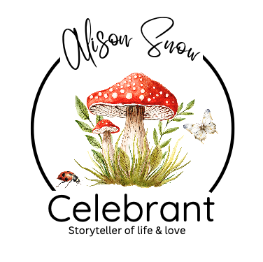
I do hope you have found this informative guide useful. I send you my congratulations and offer my services as your celebrant if you live in the Norfolk, Suffolk areas of the UK.
Alison Snow Celebrant
www.alisonsnowcelebrant.co.uk
info@alisonsnowcelebrant.co.uk
Tel: 07799 807337
This guide is the intellectual property of Alison Snow, Celebrant.
Any reproduction, distribution, or use, for any other event, or purpose—whether in part or in full—is strictly prohibited without prior written consent from the author. Unauthorized use may result in legal action

